Regulatory Committee
Meeting to be held on 11 March 2020

Part I

Electoral Division affected:
Preston West

Wildlife and Countryside Act 1981
Definitive Map Modification Order Investigation
Addition of Footpath between Lightfoot Lane and Tanterton Hall Road, Preston
File No. 804-379a
(Annex ‘A’ refers)

Contact for further information:
Simon Moore, 01772 5331280, Paralegal Officer, Legal and Democratic Services, simon.moore@lancashire.gov.uk
Jayne Elliott, 07917 836626, Public Rights of Way, Planning & Environment Group, Jayne.elliott@lancashire.gov.uk

Executive Summary

Application for the addition to the Definitive Map and Statement of Public Rights of Way of footpath lengths between Lightfoot Lane and Tanterton Hall Road, Preston, in accordance with file 804-379a.

Recommendation

That the application to add to the Definitive Map and Statement footpath

lengths between Nog Tow and Tanterton, Preston, in accordance with file 804-379a, be accepted.

That an Order be made pursuant to Section 53 (2)(b) and Section 53 (3)(b)

and/or Section 53 (c)(i) of the Wildlife and Countryside Act 1981 to add two footpaths between Lightfoot Lane and Tom Benson Way and between Tom Benson Way and Tanterton Hall Road, Fulwood, Preston City to the Definitive Map and Statement of Public Rights of Way as shown on Committee Plan between points A-B-C and D-E-F-G-H-I-J-K-L.

That being satisfied that the higher test for confirmation can be met the Order

be promoted to confirmation.

Background

In 2000, an application under Schedule 14 of the Wildlife and Countryside Act 1981 was received for the addition of a number of footpaths which were described by the applicant as being situated on land forming part of Ingol Golf Course and as having been provided by the former Central Lancashire Development Corporation.

Five separate sets of routes were listed and numbered 1 to 5 and evidence in support of each route was provided.

The application was originally submitted by the Area Footpath Secretary of the Ramblers Association (Mid Lancashire Area) but sadly, since submission, the applicant has died.

Soon after the application was submitted, research was carried out by two former members of the county council's Public Rights of Way team and initial consultations carried out but reports were never prepared or presented to the Regulatory Committee and the officers originally involved in the investigation have subsequently retired. Various development proposals were thought likely to accommodate the routes but this has not been achieved. Further work has now been done to get the reports finalised.

The original application made by the Ramblers Association was split down into five separate ones. The bulk of the evidence provided by the Applicant in support of the applications consisted of completed user evidence forms and on a review of the application bundle it has been decided to consider each route separately.

This report considers the route referred to as 'Route 1' – the addition of footpath length from Lightfoot Lane to Tom Benson Way and continuing to meet Footway F8513 at Tanterton Hall Road. It is shown between points A-B-C and D-E-F-G-H-I-J-K-L on the Committee plan.

When an application is made, the county council is required by law to investigate the evidence and make a decision based on that evidence as to whether a public right of way exists, and if so its status. Section 53(3)(b) and (c) of the Wildlife and Countryside Act 1981 set out the tests that need to be met when reaching a decision; also current Case Law needs to be applied.

An order will only be made to add a public right of way to the Definitive Map and Statement if the evidence shows that:

- A right of way “subsists” or is “reasonably alleged to subsist”

An order for adding a way to or upgrading a way shown on the Definitive Map and Statement will be made if the evidence shows that:

- “the expiration… of any period such that the enjoyment by the public…raises a presumption that the way has been dedicated as a public path or restricted byway”

When considering evidence, if it is shown that a highway existed then highway rights continue to exist (“once a highway, always a highway”) even if a route has since become disused or obstructed unless a legal order stopping up or diverting the rights has been made. Section 53 of the Wildlife and Countryside Act 1981 (as explained in Planning Inspectorate’s Advice Note No. 7) makes it clear that considerations such as suitability, the security of properties and the wishes of adjacent landowners cannot be considered. The Planning Inspectorate’s website also gives guidance about the interpretation of evidence.

The county council’s decision will be based on the interpretation of the evidence discovered by officers and documents and other evidence supplied by the applicant, landowners, consultees and other interested parties produced to the county council before the date of the decision. Each piece of evidence will be tested and the evidence overall weighed on the balance of probabilities. It is possible that the council’s decision may be different from the status given in any original application. The decision may be that the routes have public rights as a footpath, bridleway, restricted byway or byway open to all traffic, or that no such right of way exists. The decision may also be that the routes to be added or deleted vary in length or location from those that were originally considered.

Consultations

Preston City Council

The City Council were consulted and responded explaining that the areas of land in Council ownership adjacent to the golf course were transferred from the Commission for the New Towns in January 1999 and that the Estates Section of the City Council had no comments to make regarding this land.

Comments from the City Council Highways Department (as they dealt with some Highways functions at that time) confirmed the physical existence of the paths claimed by the Ramblers Association and the department states that they have always been aware of the paths and that they were created by the Central New Towns Commission. They could offer no evidence of use of the paths but reported that they had received numerous enquiries from the public about the condition of the paths and had observed that local residents believed the paths to be public footpaths.

Applicant/Landowners/Supporters/Objectors

The evidence submitted by the applicant/landowners/supporters/objectors and observations on those comments are included in Advice – Head of Service – Legal and Democratic Services Observations.

Advice

Head of Service – Planning and Environment

Points annotated on the attached Committee plan.

Point | Grid Reference (SD) | Description
A | 5106 3323 | Open junction with Lightfoot Lane north east of 147A (Thorpe Lodge)
B | 5108 3319 | Wooden stile across the route
C | 5109 3317 | Open junction with north side of Tom Benson Way adjacent to 149 Lightfoot Lane
D | 5109 3316 | Open junction with south side of Tom Benson Way directly opposite point C
E | 5107 3311 | Route crossed by old field boundary and original site of wooden stile
F | 5103 3309 | Edge of woodland
G | 5101 3307 | Ditch crossing
H | 5096 3305 | Ditch crossing
I | 5091 3303 | Edge of woodland adjacent to boundary of New Rough Hey Housing Estate
J | 5093 3299 | Edge of woodland
K | 5109 3290 | Fence across the route
L | 5113 3283 | Open junction with Footway F8513 at Tanterton Hall Road

Description of Route

The application was submitted in 2000 but a site inspection was not carried out by the county council until 2006. Although the route has recently been inspected because the application relates largely to user evidence predating 2000 details of the 2006 site inspection are included in this report rather than a detailed description of the site in 2016 because the 2006 inspection provides a better indication of what existed on the ground closer to the time that the routes were said to have been used.

Route A-B-C

The route is approximately 70 metres long and commences on Lightfoot Lane, at point A on the Committee plan. In 2006 it was reported that there was a grey metal post to the westerly side of the start of the route. The officer carrying out the site inspection considered that the post appeared to have been a footpath direction sign although noted that the fingerpost was missing. The route was described as extending from the rear of the footway, over a macadam surface. After approximately 4 metres the surface changed to stone and remained approximately 2 metres wide and in good condition. There was a timber panel fence to the easterly side with a mature hedge to the westerly side. After approximately 30 metres a timber panel fence took the place of the hedge.

At point B on the committee plan it was reported that there was a substantial timber, two-step stile between the two timber panel fences. This stile was in very good condition and the officer carrying out the investigation considered that it had been installed by the Central Lancashire Development Corporation.

From point B it was reported that the stone surface continued for approximately 15 metres with the timber fence to the westerly side and an open grass verge to the east to Tom Benson Way, B6241, at point C.

In summary, in 2006 the whole of the claimed route between point A-C was reported to be clear and easily available for public use with a firm and level surface throughout. The stile at point B was of the design used by the Development Corporation and the route appeared to have been signed in the past.

When the route was re-inspected in 2016 it was found still to exist on the ground. The remains of a metal post was still visible at point A and the wooden stile still existed at point B. The route was overgrown but passable.

Route D-E-F-G-H-I-J-K-L

The route is approximately 565 metres long between points D-E-F-G-H-I-J-K-L.

The route commences on the south side of Tom Benson Way directly opposite point C. In 2006 it was reported that access onto the route at point D was open and unrestricted but that between point D and point E the route was inaccessible due to overgrowth. A trodden route from point D heading in a more southerly direction was reported to exist which provided access to the golf course and then south west to meet point E.

At point E there was a timber, two-step stile, in a section of timber railing fence which appeared to the officer making the inspection to have been installed by the Development Corporation and was reported to be in good condition. The area around the stile was badly overgrown and inaccessible.

From point E the route claimed continued in a west south westerly direction along the edge of the golf course following a faint trodden path before entering the woodland at point F near a stone gatepost with white paint on its top part.

It was noted that the route through the woodland was difficult to identify and there was no visible path through the planting although the trees had been planted in rows, which could easily have accommodated a route between. Storm damage and lack of maintenance was referred to which had resulted in branches falling onto the ground along the route claimed and making access difficult.

At point G there was a wooden railway sleeper crossing of small dry ditch. It was described as being a single sleeper in poor condition.

At point H there was a second damaged railway sleeper ditch crossing on the claimed route, which was noted as originally being 10 sleepers wide. Although it had suffered from damage and rotted, it could still be used with care. The ditch that it crossed was noted as being shallow and dry, even after a prolonged period of heavy rain when the inspection was carried out.

Further brambles and overgrowth were reported on the section leading from point H to point I and then south east to point K with various alternative paths through and into the woodland referred to.

From point I the route was described as running generally parallel to metal fence enclosing the housing development to the west.

The route from point I to point J was described as being divided from this development by a metal security fence with no formal access available from the development, although there was an area where the fence had been damaged and access had been gained onto the golf course. This length of the claimed route was noted as being available for use although there was no trodden path visible and there were areas where rubbish had been left on the land causing obstructions.

From point J to point K the route was reported to be overgrown with various trodden routes through and round the overgrowth but with no clearly defined use of the claimed route.

At point K the route was blocked by metal security fencing and to the south east of the fencing were four concrete bollards positioned across the route. Beyond that a clearly defined and laid out pathway existed along the north eastern perimeter of the housing development but was largely overgrown and obstructed by garden waste through to point L where it met the adopted footway on the north side of Tanterton Hall Road, U 10657, at the point where the footway from the east and the footway from the south and west join. A section of brickwork across the path at a low level which could be stepped over was reported at point L.

In summary, it appeared to the officer carrying out the site inspection in 2006 that a route was originally laid out by the Development Corporation along the alignment of the route claimed including sections of surfaced path, a route through the woodland with sleeper crossings of ditches, and stiles in sections of fences but that since the provision of this route it had become overgrown and obstructed at various locations with members of the public making unofficial alternative routes to avoid them.

When the route was re-inspected in 2016 there was no visible trace of the route between point D and point E. The stile at point E was no longer in existence and although various trodden pathways existed across the land and through the woodland most of the route between points E-F-G-H-I-J-K was overgrown and difficult to follow. The security fencing blocking access at point K was still in place and concrete bollards still evident. Between point K and point L the laid out, surfaced section of the route was visible and passable with much of the garden waste and overgrowth that covered the route in 2006 having been removed.

Map and Documentary Evidence

A variety of maps, plans and other documents were examined to discover when the route came into being, and to try to determine its status. The route is not shown on any of the early commercial maps, the Tithe Map of Broughton dated 1839 or OS maps published in 1849, 1893, 1912, 1932, 1938, 1961 or 1978. Neither is it shown on the aerial photographs taken in the 1940s or 1960s.

The route crosses land which is within an area which was designated as the Central Lancashire Development Corporation. A Development Corporation was a body set up across parts of England and Wales and charged with the urban development of an area. It operated under the New Towns Act of 1965, outside the usual Town and Country Planning legislation.

The Central Lancashire New Town (Designation) Order was approved on 14 April 1970 and the Development Corporation formerly constituted on 17 February 1971. The Commission was in existence for 16 years until it was formally dissolved on 31 March 1986 and during that time the area to the north of Preston – referred to as Ingol East – underwent significant development.

The application route came into existence as part of the development of Ingol East – with particular reference to an Extinguishment Order under The New Towns Act 1965, which was made on 29th June 1978 by the Secretary of State for the Environment. The New Towns Act gave the power to extinguish existing public rights of way to allow for development, and alternative paths were often shown on plans accompanying extinguishment orders. The New Town Commission could create new highways like any other owner.

The routes claimed were described in the application as having been provided by the former Central Lancashire Development Corporation as a replacement for Fulwood Footpath 49 and Lea Footpath 43 which were extinguished by the 1978 Order and further details of the order and evidence post-dating the designation of the area as part of the Central Lancashire New Town are detailed below and assessment made of the relevant map and documentary evidence discovered:

Document Title | Date | Brief Description of Document & Nature of Evidence
Definitive Map Records |  | The National Parks and Access to the Countryside Act 1949 required the county council to prepare a Definitive Map and Statement of Public Rights of Way.  Records were searched in the Lancashire Records Office to find any correspondence concerning the preparation of the Definitive Map in the early 1950s.
Parish Survey Map | 1950-1952 | The initial survey of public rights of way was carried out by the parish council in those areas formerly comprising a rural district council area and by an urban district or municipal borough council in their respective areas. Following completion of the survey the maps and schedules were submitted to the county council. In the case of municipal boroughs and urban districts the map and schedule produced, was used, without alteration, as the Draft Map and Statement. In the case of parish council survey maps, the information contained therein was reproduced by the county council on maps covering the whole of a rural district council area. Survey cards, often containing considerable detail exist for most parishes but not for unparished areas.
Observations |  | Fulwood was an Urban District Council for which no parish survey was carried out.
Draft Map |  | The Draft Maps were given a “relevant date” (1st January 1953) and notice was published that the draft map for Lancashire had been prepared. The draft map was placed on deposit for a minimum period of 4 months on 1st January 1955 for the public, including landowners, to inspect them and report any omissions or other mistakes. Hearings were held into these objections, and recommendations made to accept or reject them on the evidence presented.
Observations |  | The routes under investigation were not shown on the Draft Map of Public Rights of Way for Fulwood and there were no representations made to the county council in relation to it.
Provisional Map |  | Once all representations relating to the publication of the draft map were resolved, the amended Draft Map became the Provisional Map which was published in 1960, and was available for 28 days for inspection. At this stage, only landowners, lessees and tenants could apply for amendments to the map, but the public could not. Objections by this stage had to be made to the Crown Court.
Observations |  | The routes were not shown on the Provisional Map of Public Rights of Way for Fulwood and there were no representations made to the county council in relation to it.
The First Definitive Map and Statement |  | The Provisional Map, as amended, was published as the Definitive Map in 1962.
Observations |  | The routes were not shown on the First Definitive Map and Statement.
Revised Definitive Map of Public Rights of Way (First Review) |  | Legislation required that the Definitive Map be reviewed, and legal changes such as diversion orders, extinguishment orders and creation orders be incorporated into a Definitive Map First Review. On 25th April 1975 (except in small areas of the County) the Revised Definitive Map of Public Rights of Way (First Review) was published with a relevant date of 1st September 1966. No further reviews of the Definitive Map have been carried out. However, since the coming into operation of the Wildlife and Countryside Act 1981, the Definitive Map has been subject to a continuous review process. By 1975 Central Lancashire Development Corporation had been in existence only four years and had just achieved its planning consent and extinguishment of footpaths 49 and 43 had not yet happened.
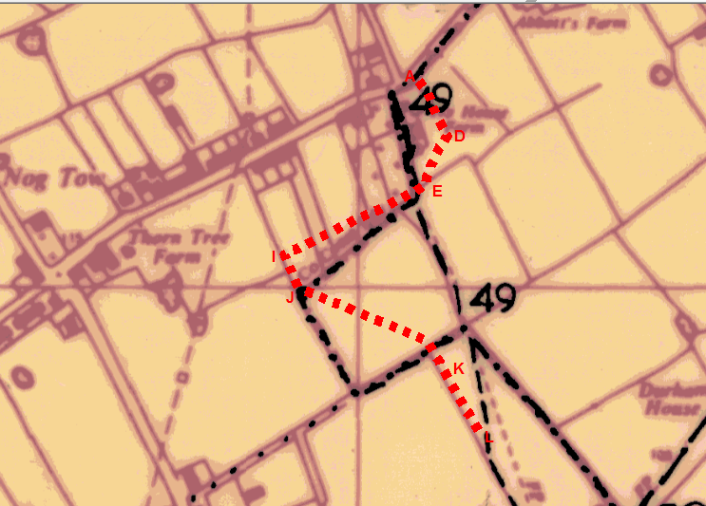
Observations |  | The routes were not shown on the Revised Definitive Map of Public Rights of Way (First Review). The dash dot line is a boundary line. Footpath 49 is the dashed line.
Investigating Officer's Comments |  | From 1953 through to 1975 there is no indication that the routes were considered to be public right of way by the Surveying Authority. There were no objections to the fact that the routes were not shown from the public when the maps were placed on deposit for inspection at any stage of the preparation of the Definitive Map.
Aerial photograph | 1960s | The black and white aerial photograph taken in the 1960s and available to view on GIS.
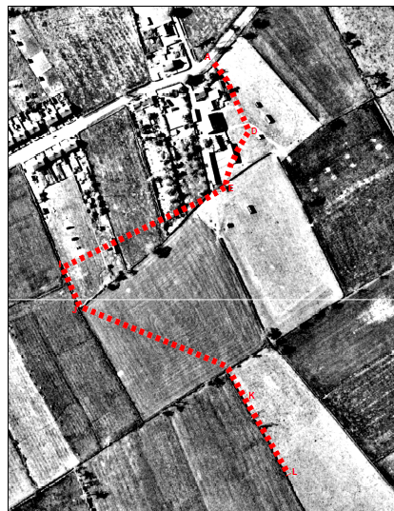
Observations |  | The routes under investigation are not shown.  The photograph predates the development of Ingol golf course, adjacent housing and construction of the Tom Benson Way.
Investigating Officer's Comments |  | The routes under investigation did not exist when the photograph was taken in the 1960s.
OS 1:2500 Map | 1963 and 1978 | 1:2500 OS map 5032 5132 revised 1960 and published 1963 and OS map 5033 5133 revised 1970 and published 1973
1963 OS

1978 OS
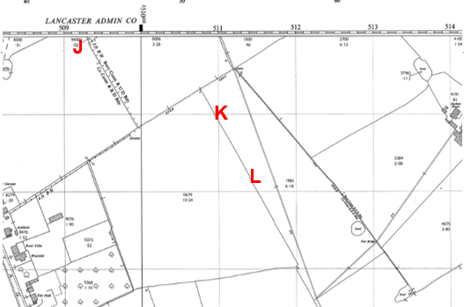
Observations |  | The routes under investigation are not shown.  Both Ordnance Survey map sheets pre date the development of Ingol golf course, adjacent housing and construction of the Tom Benson Way.
Investigating Officer's Comments |  | The routes under investigation did not exist between 1963 and 1978.
Central Lancashire Development Corporation Planning Statement | 1974 | Copy of Central Lancashire Development Corporation Ingol East, Residential and Associated Development Planning Statement prepared with reference to Section 6(1) New Towns Act 1965
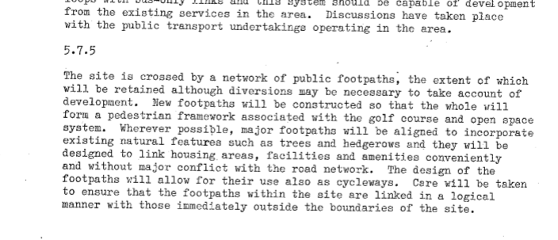
Observations |  | A copy of the Planning Statement prepared in relation to the development of the area crossed by the application route was obtained from the submissions made in relation to a request for planning permission in 2010 (Ref 06/2010/0626).  The Planning Statement was prepared in 1974 by the Development Corporation seeking approval to develop the Ingol site under the New Town legislation. It explains that the site – consisting of 430 acres – was in 22 ownerships all of which were being purchased by the Commission under compulsory purchase orders with the exception of the land owned by Preston Borough Council which was being transferred by agreement. The Statement lists the development proposals including housing, schools and other facilities, the golf course, public open spaces and communications.  Under the heading titled 'Communications' is a paragraph 5.7.5 relating to public rights of way which explains that the existing extent of public rights of way will be retained – or diverted where necessary to allow for development - and that a new network of footpaths would be constructed to link housing areas, facilities and amenities the design of which would also allow for use as cycleways.
Investigating Officer's Comments |  | Whilst not specifically referring to the creation of 'public' footpaths the inference is that the land to be developed – which would all be within the ownership of the Central New Town Commission – would be developed in such a way as to include a network of existing and additional footpaths to be used by the public on foot and also capable of being used on bicycle.
Central Lancashire Development Corporation plan 'Ingol East' | 1977 | Plan deposited in the County Records Office dated 1977 at a scale of 1:2500 and referenced as Drawing No. 6/34/17c (CRO reference NTC5/2/53). Originally titled as 'Support Drawing' which is crossed out in pen and replaced by 'Local Plan'.

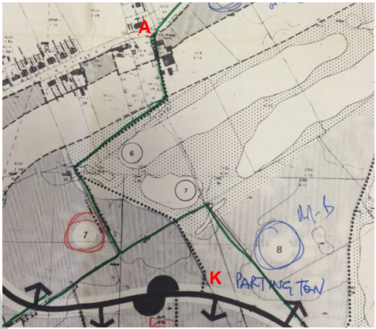
Observations |  | The plan shows the routes under investigation marked by dots as 'pedestrian access'. Tom Benson Way's actual carriageway width is not shown on the plan but its corridor is shown and the route of Tannterton Hall Hey is shown as 'Future Distributor Road'
Investigating Officer's Comments |  | This is the earliest plan inspected to show the route crossing land to be developed as part of the golf course. The route is described as 'pedestrian access' although there is no indication on the plan whether this referred to the dedication of a public right of way.
Final Draft Agreement for lease relating to development of golf course and housing | 1978 | A copy of a draft agreement was found in the County Records Office annotated as being the 'final draft agreement' between Central New Towns Development Corporation and Miller Buckley Golf Services (Ingol) Limited dated 13 March 1978 for the lease relating to the development of the golf course and housing.
Observations |  | The agreement contains information regarding the provision of footpaths across the land. Within Schedule 3 it states that within the golf course parcel the corporation will provide certain footpaths shown on a drawing referenced 6/34/308A and that the general line of these footpaths may be subject to variation by agreement between the corporation and the company. It also stated that any closure of an existing footpath will require an order which is within the discretion of the Secretary of State.  The agreement also stated that footpaths must be kept open and useable on foot at all times although private footpaths could be temporarily closed by the lessee if necessary for the proper management of the golf course and that the corporation would not unreasonably withhold permission to divert public or private footpaths at a future date if it was necessary for the implementation of the scheme.
Investigating Officer's Comments |  | A copy of the plan referred to in the agreement could not be found in the County Records Office so it is not possible to confirm whether the routes under investigation were the ones shown. However, the draft agreement does refer specifically to the provision of public access along footpaths across the site although it appears that there were to be both public and private routes created.
New Towns Act 1965  Order for the Extinguishment of Public Rights of Way  Central Lancashire Development corporation  Borough of Preston | 1978 | Order made by Secretary of State on 29th June 1978 to extinguish parts of Footpaths 41, 43, 49, 48, 50, 42 and 5 as shown on the Order plan and described in the Order Schedule.
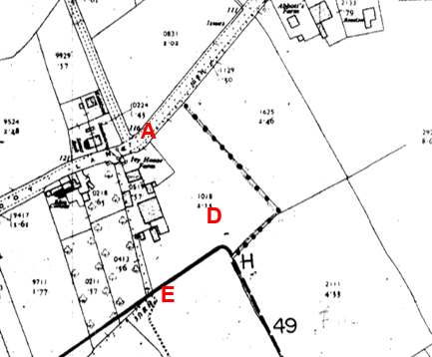
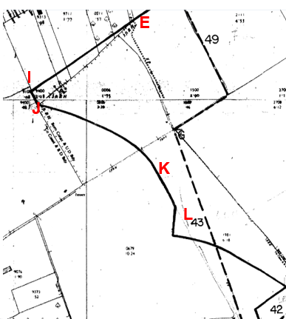
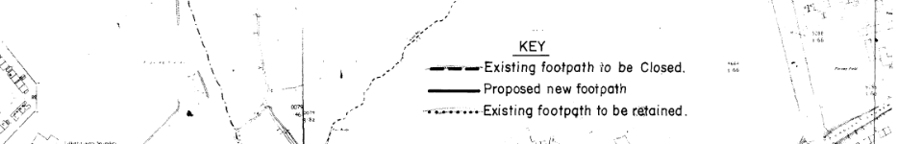
The Order came into effect on the day that it was made. There was no reference to the creation of alternative or 'new' public rights of way in the wording of the Order but the key to the Order plan showed proposed new footpaths with a solid black line, existing footpaths to be closed with a long dashed line and existing footpaths to be retained by short dashed lines.
The route under investigation between points A-B-C and D-E is not shown on the plan as an existing path to be retained or as a proposed path on the Order plan but a route is shown to the west of it as an existing footpath to be retained linking Lightfoot Lane to the original route of FP 49 (to be extinguished) and then from there along a line marked as proposed footpath to point E. From point E the proposed footpath is shown consistent with the route under investigation to continue along the application route between points E-F-G-H-I-J-K-L.
Observations |  | The Order plan showed a number of routes by the use of short dashed lines which were described as existing footpaths to be retained but which were not recorded as public footpaths. It also showed "proposed new footpaths" – including part of the route under investigation from point E-L.  It appears that an Order was made to extinguish a number of existing footpaths but that a number of other paths already existed on the ground which were not proposed to be extinguished but which would link to paths to be created as alternatives to those extinguished. Part of the route under investigation (from point E-L) was shown on the plan as a proposed route to be created. The Order does not specify that the route was to be created as a public right of way by the Order, Central Lancashire Development Corporation could create highways as owner but it appears reasonable to infer that the intention was to create alternative public rights of access along the routes shown as proposed new routes.
Ingol Golf Villages - Leaflet published and produced by Central Lancashire Development Corporation | 1980 | Copy of leaflet produced providing details of the proposed development of a golf course and housing in Ingol and contact details for the various housing developers and Central Lancs New Towns Development Corporation. The leaflet included a map of the 18 hole golf course and the key to the map details, amongst other things, routes shown as public footpaths, existing and new roads and roads to be made into footpaths.
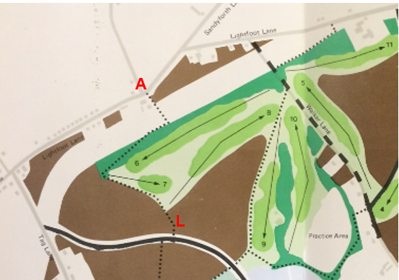
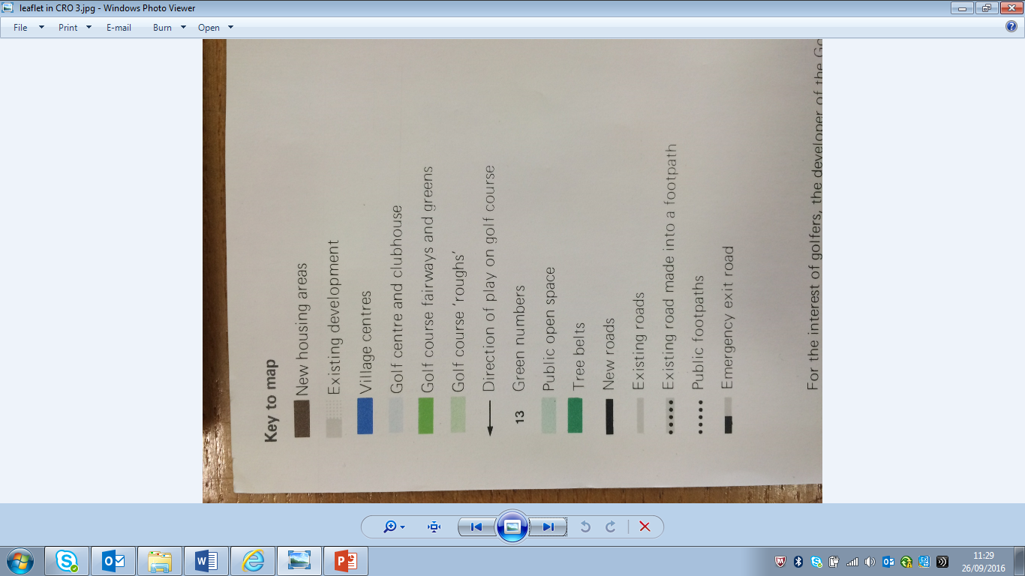
Observations |  | Tom Benson Way is not shown but a route shown as a public footpath is clearly shown corresponding to the application route from point A through to point L and linking to Tanterton Hall Road.
Investigating Officer's Comments |  | The leaflet was distributed to the public showing details of the proposed development and clearly indicates the intention that the application route was to be provided as a public footpath reiterating the intention to provide alternative routes for those paths extinguished by the 1978 Order detailed above.
Aerial Photograph |  | Aerial photograph available to view in the County Records Office.
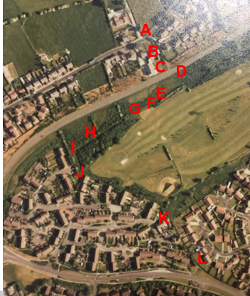
Observations |  | The photograph has been enlarged but it is still difficult to see parts of the route due to its scale and shadowing from houses and trees.  Part of the application route can be seen between point B and point C leading out onto Tom Benson Way. Between D and E the route is not visible although a route can be seen along the edge of the golf course running to point E. No worn track can be seen between point F and point G and from point G the route passes into woodland where a line consistent with the application route can be seen extending from point G to point H and through to point I. A worn track cannot be seen between point I and point J or along the boundary of the golf course to point K. Between point K and point L parts of the route are visible – particularly leading up to point L.
Investigating Officers Comments |  | Traces of parts of the route can be seen as worn paths but it is not possible to determine whether the full length of the route was open and accessible at that time.
Plan used as part of application to show route | 1998 | Plan provided by Commission for New Towns (North) to the applicant together with a letter in response to the applicant querying the status of the application route with them prior to submitting the application.
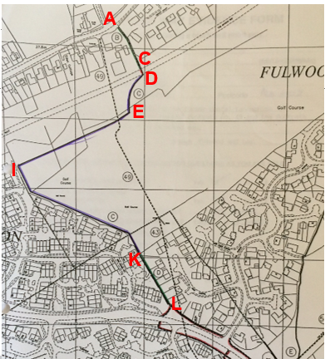
 |  |  | 
Observations |  | This plan was provided to the applicant by Mr R Robson, Commission for New Towns (CNT) North, in a letter dated 06 November 1998. The drawing – referenced CNT/CL/E6133, is stated to be based on the latest OS plan of the Ingol and Tanterton area (at that time) and is described as being marked up with the routes of the former footpaths and the approximate routes of the various alternative footpaths provided in respect of the various footpath closures.  The plan was marked up with details of the various landowners and annotated with letters of the alphabet.  With regards to 'Route 1' the following comments were made in the letter by Mr Robson:  Length B (Point A-B-C on Committee plan) – described as an 'amenity footpath' and alternative to Footpath 49 in the ownership of Preston Borough Council.  Length C (Point D-E-F-G-H-I-J-K) described as an alternative to Footpaths 43 and 49 in the ownership of Ingol Golf Course. It was also noted that the route deviated from the intended route at the north edge of the golf course).  Length D (Point I-J on the Committee plan) – described as an alternative to Footpath 43, owned by Preston Borough Council.  The letter accompanying the plan also explains that Central Lancashire Development Corporation sold the golf course to Hemm Inns Limited in 1985 and put provisions in the transfer to ensure that the footpaths indicated in the original layout approved in 1978 were not obstructed or interfered with. The lines of the routes across the golf course are indicated in blue but CNT make reference to the routes now in use deviating from the routes marked in blue in several places.
Investigating Officer's Comments |  | The letter and plan provide further evidence regarding the construction of the application route as an alternative to those routes extinguished to allow for the development of the site and evidence of intention to dedicate by the owner.  The letter appears to suggest that whilst the route was originally provided on the route shown the public had subsequently deviated from the route in a number of unspecified locations.
Land Registry Title Number LA512320 | 1985 | The land covered by this title includes the application route between points D-K.
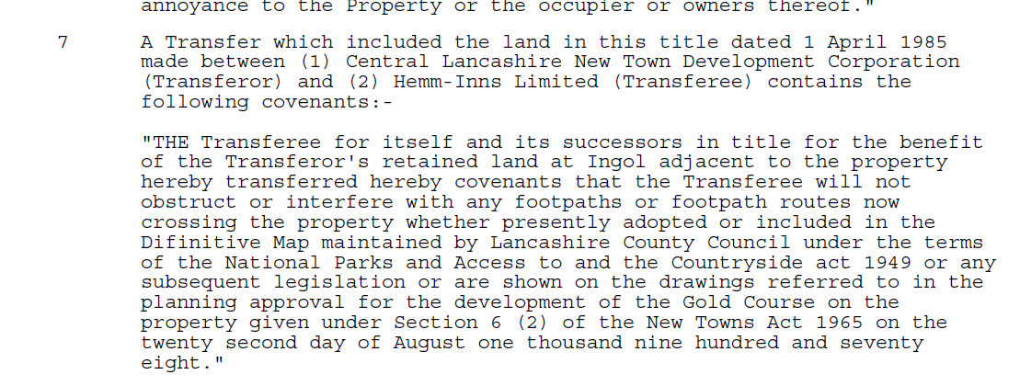
Observations |  | The transfer of land from the Central Lancashire New Town Development Corporation to Hemm-Inns Limited included a covenant regarding footpaths or footpath routes which were either currently recorded on the Definitive Map, were adopted, or which were shown on drawings referred to in the planning approval for the development of the golf course on 2nd August 1978. The covenant specified that those routes should not be obstructed or interfered with.
Investigating Officer's Comments |  | There appears to be a clear intention by the Central New Towns Development Corporation that all existing public footpaths and proposed public footpaths across the land sold should be recognised and protected against future obstruction or interference.
Statutory deposit and declaration made under section 31(6) Highways Act 1980 |  | The owner of land may at any time deposit with the County Council a map and statement indicating what (if any) ways over the land he admits to having been dedicated as highways. A statutory declaration may then be made by that landowner or by his successors in title within ten years from the date of the deposit (or within ten years from the date on which any previous declaration was last lodged) affording protection to a landowner against a claim being made for a public right of way on the basis of future use (always provided that there is no other evidence of an intention to dedicate a public right of way).  Depositing a map, statement and declaration does not take away any rights which have already been established through past use. However, depositing the documents will immediately fix a point at which any unacknowledged rights are brought into question. The onus will then be on anyone claiming that a right of way exists to demonstrate that it has already been established. Under deemed statutory dedication the 20 year period would thus be counted back from the date of the declaration (or from any earlier act that effectively brought the status of the route into question).
Observations |  | No Highways Section 31(6) deposits have been lodged with the County Council for the area over which the Route runs.
Investigating Officer's Comments |  | There is no intention by a landowner under this provision of non-intention to dedicate public rights of way over their land.
Aerial Photograph | 2000 | Aerial photograph available to view on GIS.
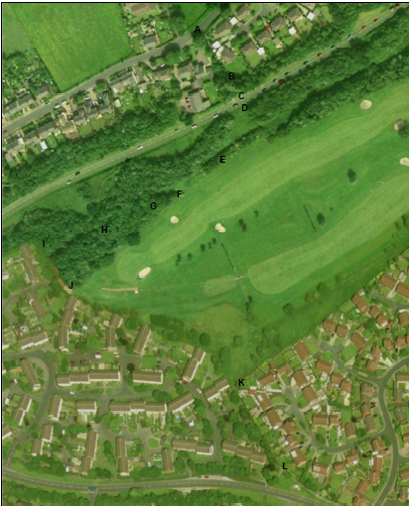
Observations |  | It is not possible to see the route between point A and point C due to tree cover although a worn area can be seen at point C where the route meets Tom Benson Way.  From point D the land crossed by the route appears open and not overgrown but is not visible on the photograph as a trodden track. A route can be seen from point D extending in a general south easterly direction through a gap in the hedge/woodland and then cutting back in a more westerly direction onto the mown area of the golf course. A route through the trees from point G to point I may have existed and from point I to point J a route can be seen on the ground.  The route is not visible on the ground as a worn track between point J and point L and it is not possible to see whether access would have been available along this section.
Investigating Officer's Comments |  | The photograph was taken the year that the application was submitted. Traces of parts of the route can be seen as worn paths but it is not possible to determine whether the full length of the route was open and accessible at that time.
Highway Adoption Records including maps derived from the '1929 Handover Maps' | 1929 to present day | In 1929 the responsibility for district highways passed from rural district councils to the county council. For the purposes of the transfer, public highway 'handover' maps were drawn up to identify all of the public highways within the county. These were based on existing Ordnance Survey maps and edited to mark those routes that were public. However, they suffered from several flaws – most particularly, if a right of way was not surfaced it was often not recorded.  A right of way marked on the map is good evidence but many public highways that existed both before and after the handover are not marked. In addition, the handover maps did not have the benefit of any sort of public consultation or scrutiny which may have picked up mistakes or omissions.  The County Council is now required to maintain, under section 36 of the Highways Act 1980, an up to date List of Streets showing which 'streets' are maintained at the public's expense. If a road is not on this record it may still be an existing highway. Alongside the List is a coloured up plan of the extent of the highways on the List. Footpaths and Bridleways are often not shown on these plans.
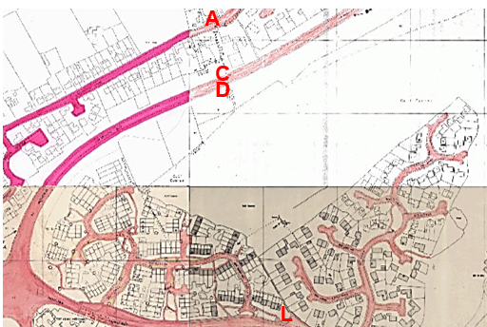
Observations |  | The claimed route is not recorded on the coloured up adoption record as being publicly maintainable. Existing Public Footpaths are not shown such as FP88.
Investigating Officer's Comments |  | The routes were not recorded as being publicly maintainable but no inference can be drawn regarding public rights.

The affected land is not designated as access land under the Countryside and Rights of Way Act 2000 and is not registered common land.

Since the applications to record public footpaths across the former golf course were submitted the golf course has ceased to operate and a number of planning applications have been submitted to Preston Borough Council for the land to be redeveloped. Two substantial applications were made in 2010 and 2014 (Planning References 06/2010/0626 and 06/2014/572). Information submitted as part of the applications was viewed and it is noted that on various plans prepared existing public footpaths are shown together with the routes applied for – which are shown separately as being routes subject to Definitive Map Modification applications.

No further information relevant to the applications was however found.

Landownership

The land crossed by the route under investigation between points A-B-C is registered in the ownership of Preston City Council. When the application was originally submitted this land was registered in the ownership of the Homes and Communities Agency which were the successor body to the Commission for New Towns.

Between points D-E-F-G-H-I-J-K the land crossed by the route under investigation is registered in the ownership of Cleator Manor Limited (since 2006). The ownership is still subject to the covenant referred to above.

Between points K-L the land crossed by the route is registered in the ownership of Preston City Council.

Summary

There is no map or documentary evidence supporting the existence of the application route prior to the development of the area by the Central Lancashire Development Corporation in the mid to late 1970's and it is clear that the route only came into being as a result of the development of the site as a golf course and residential area.

The first plan found as part of this investigation which showed the route is dated 1977 and shows the route as 'pedestrian access'. A year later, in 1978, an extinguishment order was made to extinguish public footpaths across the site to enable development to take place. The Order included a plan and written schedule which detailed the application route as a 'proposed new footpath' and the order came into effect once made. The Central Lancashire Development Corporation had legal power to extinguish routes by order and it appears from further maps, plans, agreements, land transfer documentation and publicity information provided in the early 1980s shows that the Development Corporation intended to provide a pedestrian route to the public.

From the Development Corporation records searched, together with the site evidence and information provided by the applicant it appears that the route was provided and was capable of being used by the public and the map and documentary evidence detailed above appears to support the user evidence submitted.

Head of Service – Legal and Democratic Services Observations

Information from the Applicant

The applicant submitted 64 user evidence forms together with a copy of a letter that she had sent to members of the Ramblers Association in August 2000 explaining that staff at Ingol Golf Club had been preventing walkers using the paths across the golf course and that she was putting together an application to record the routes on the Definitive Map and asking people to complete user evidence forms if they had used the routes.

The user evidence forms all included a map provided by the applicant showing the route claimed.

5 of the forms stated that the users had known the route for more than 50 years and that they had walked the area prior to development. One user claimed to have known the route all his life and wrote that he was 71 years old. A further form stated that the user had known the routes since they had come into existence but failed to specify any dates.

9 users claimed to have used the path in excess of 20 years providing dates ranging between 1972 and 2000. A further 14 users had used the route for between 15 and 20 years between 1980 and 2000.18 users stated they had used the route for between 10 and 15 years during the period 1980 to 2000 and 13 users specified less than 10 years use during that period.

All of the users completing the forms stated that they regarded the path as public. Use was primarily for leisure with a high percentage of users stating that they used the route to walk their dogs. Other reasons for using the path were listed as visiting friends, going to the pub, feeding the ducks, for exercise and for recovery from ill health.

3 of the users make reference to the fact that the route between point D and point E was overgrown and that they had been using an alternative path (not marked) to get round it.

One user stated that he worked as a security and maintenance officer at Ingol golf course and that he used the route 2 or 3 times a day as part of his employment. He stated that he considered the route to be public and had used it for 18 years. He refers to having to deal with various anti-social issues on the land including issues with dog walkers and vandalism.

Information from the Landowner

Following receipt of the application consultations were carried out with the owners of Ingol Golf Course at that time (Tee Jay Leisure Limited, Sagar House, Eccleston, Chorley). They instructed Kevills Solicitors who requested a meeting with the County Council in 2006 in the hope that a 'pragmatic solution' could be found.

No meeting was arranged and a further Land Registry search has identified that some of the land crossed by the application routes was subsequently sold to Cleator Manor Limited.

English Partnerships were consulted and replied with details of land ownership stating that length J - M (now L – D) crossed land owned by Preston City Council and Ingol Golf Course and length N – O (now C – A) crossed land owned by Preston City Council at the time of consultation.

Assessment of the Evidence

The Law - See Annex 'A'

In Support of Making an Order(s)

User evidence
Evidence of Central Lancashire Development Corporation's intention.

Against Making an Order(s)

Actual Central Lancashire Development Corporation planning consent drawings not available.

Conclusion

As there is no express dedication it is advised that Committee consider whether there is sufficient evidence on balance for a deemed dedication from use under S31 Highways Act 1980 and/or an inferred dedication at common law from all the circumstances pointing to an intention to dedicate by the owner.

It would seem to be the case that the route did not exist prior to the ownership by Central Lancashire Development Corporation established by the Minister under the New Towns Act 1965. The land for the golf club had been taken by the Commission by compulsory purchase powers or in the shadow thereof and planning consent obtained by the Commission by submitting proposals and the Minister making a Development Order. The Development Order and its drawings has not been located but it is suggested that other documents are of assistance.

At common law to infer a dedication from all the circumstances can involve consideration of both user evidence and documents. The Planning Statement referred to earlier in the report clearly shows that the Central Lancashire Development Corporation had an intention to create footpaths and to retain the extent of the existing network. The New Towns Act says that a Development Corporation had the power to do anything necessary or expedient for the purposes incidental to its main objectives. Central Lancashire Development Corporation is obviously unusual as it was developing huge areas of land.

Committee must consider whether there is sufficient evidence of the intention to create the actual route being considered in this report.

It is suggested that there is sufficient evidence to indicate an intention to dedicate this claimed route – save for a different line D-E in the planting swathe of Tom Benson Way - appears on the "Local Plan" appearing to be the replacement for FP49 and to a large extent on the Order plan itself re the extinguishment of existing footpath and on the leaflet produced by the owners and the plan supplied by CNT.

The route has actually been constructed on the ground for some of its length and the style of construction and of stiles would seem on the information to be consistent with that of the Central Lancashire Development Corporation.

The blocking of the route at point K blocked a laid out pathway.

The unavailability of length D-E and difficulty accessing the route in the woodland in 2016 does not mean that it was not available when created and up to 2000 when the application arrived.

The user evidence is significant and collected and submitted by the Ramblers Association.

The user adds force to the evidence of Central Lancashire Development Corporation's intention to dedicate this route and accepts the routes on the part of the public.

It is suggested that Committee may find sufficient evidence from which to infer an actual dedication by Central Lancashire Development Corporation and acceptance by the public can reasonably allege to have occurred or found to have occurred on this claimed route.

The user evidence also enables Committee to consider whether as of right use has been for the twenty years without interruption and without indication of a lack of intention to dedicate such that dedication may be deemed to have occurred under S31 Highways Act 1980. Again the user evidence is supported by plans completed by the users and collected by the Ramblers Association. There is reference to use by the Association for guided walks. It is suggested that the calling into question was the submission of the application or possibly just before then when the challenges by the Golf Club are referred to. It is advised that the user evidence is sufficient for which to deem dedication.

Taking the evidence into account it is suggested that the Committee may decide that an Order can be made for this route to be added to the Definitive Map and Statement and be promoted to confirmation.

Risk Management

Consideration has been given to the risk management implications associated with this claim. The Committee is advised that the decision taken must be based solely on the evidence contained within the report, and on the guidance contained both in the report and within Annex 'A' included in the Agenda Papers. Provided any decision is taken strictly in accordance with the above then there is no significant risks associated with the decision making process.

Local Government (Access to Information) Act 1985

List of Background Papers

Paper | Date | Contact/Directorate/Tel
All documents on File Ref: 804-379a |  | Simon Moore, 01772 5331280, County Secretary and Solicitors Group
Reason for inclusion in Part II, if appropriate

N/A

